SNHU CS 320 Software Test, Automation, QA
Professor Kalysa Wislon
Alan Davis
12-14-2025

Project Two Summary and Reflections
Throughout the development of the mobile application, I was provided with requirements necessary to deliver the final product. I focused my development and testing efforts around these requirements. This involved creating the base software with methods to validate each attribute and other necessary methods such as adding, deleting, and updating. Let’s look at the Contact and ContactService Classes for examples. The firstName attribute had the following requirements: the string length cannot be less than one, the string length must not be greater than ten, and the string must not be null. This means I needed to have a method to validate that a firstName is provided and between one to ten characters before a Contact is created or updated.
The product that I have created meets the requests of the customer and is adequately tested. I feel confident in that answer based on my methodology of testing and the overall coverage of my tests. I will describe these techniques in further detail later, but I designed tests that that ensured the target code was operating as intended and it properly threw exceptions when expected errors occurred. If we look at the firstName from Contact Class again, we can see some of the tests that would arise. We want to make sure we test when firstName is created or updated with one to ten characters, less or more than one to ten characters, and null. This should cover many of the successful and unsuccessful uses of this attribute. These tests were created for every attribute, method and constructor. The overall statement coverage provided from these tests is between 81% to 100%. The tests exercised at least 80% of the code base all the way up to 100% of it. If the test coverage was lower, then certain aspects of the code went unexercised, and I would not know what happens when those parts of the code are exercised.
I got my test coverage to 100% in some areas of my code, does that mean that those areas are error free? Unfortunately, no. The higher the test coverage translates to the code being exercised. I also want to the code and tests to be technically sound. This would mean going past just exercising the code and ensuring sure that the objective of a method or aspect of the code is performing the correct action. The following screenshot is an example of ensuring the correct action is taking place and not just exercising the underlying code base.
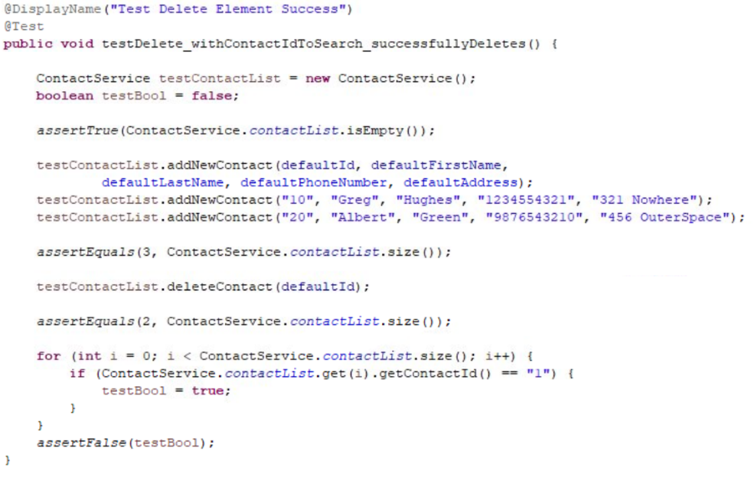
I verify that the deleteContact method works in a few ways. First, I check that the contactList is empty to start. Then I add three Contacts with different IDs. I add more than one Contact so I can check that only one Contact is deleted and not the entire list. I check that the list now has a size of three to match the added number of Contacts. I choose to delete the contact with ID of “1” which is the defaultId. I again check the size of the contactList to make sure it’s now a size of two. The last check is done by looping through the contactList to see if a Contact has the deleted contactId of “1”. As long as the Contact was deleted, testBool will not be updated and the final assertion will assert that testBool is still false. This goes beyond exercising the code base. This checks on several levels that only a specific Contact is deleted.
Another important aspect of software development is efficiency. I developed the program and tests with efficiency in mind. I did this in several different ways. The most obvious is the implementation of code reuse. In each of the contact, appointment, and task classes I used a validation method that both the setter method and constructor implemented. This keeps the constructor and setter methods more streamlined and easier to understand and reduces the overall amount of code. I also kept my code efficient by using descriptive global variables for different test values of my code. For the firstName attribute, we could have each test have a single character in the test like “a”. This however can end up being harder to interpret. I can instead create a global variable named VALID_FIRSTNAME_MIN and assign it a single character like “A”. Now when reading through the test you can easily identify that for the firstName attribute we are using the minimum valid test value. This can make it easier to identify what values are being tested for and more efficiently change the values if the underlying parameters for the attributes need to be changed later.
As I mentioned earlier, I employed a suite of different testing techniques. Those techniques involved static testing, dynamic testing, boundary value analysis, and equivalence partitioning. Static testing is a technique the involves inspecting the code base, requirements documents, user stories, and other documents that go into creating the software without ever exercising the code base. This technique was useful to find errors that would not be picked up by exercising the code and preventing errors from reaching later stages of testing (Hamblin et al., 2019). Specifically, there were times where the tests would run tests successfully, but I forgot to change the value of an attribute or the name of the test. This would mean that my tests will produce the correct response but it’s not developed for what the test intended. Dynamic testing is the act of testing the software while exercising the code base. Certain errors can only be uncovered by exercising the software (Hamblin et al., 2019). It is also helpful as the errors are marked and can point me to specific lines of code I need to review more closely. This helped me uncover errors where I was using a getter method to grab the wrong attribute which would cause my JUnit test to fail since an exception was being thrown instead of successfully updating an attribute.
Outside of dynamic and static testing, I used the techniques of boundary value analysis and equivalence partitioning as complimentary techniques. We established earlier that most of my testing was focused on the attributes of each base class (Contact, Appointment, and Task). Thes attributes all had specific acceptance criteria which provide excellent guidelines for implementing equivalence partitioning. Equivalence partitioning focuses on grouping specific inputs into buckets of either acceptable or unacceptable inputs (Hamblin et al., 2019). For the firstName attribute, this would be broken into a single bucket of acceptable inputs being strings of one to ten characters and unacceptable buckets of null, string of less than one characters, and string of more than ten characters. We can then apply boundary value analysis to create our different set of tests to perform. Boundary value analysis shows us that errors typically appear around the boundary of acceptable and unacceptable inputs (Hamblin et al., 2019). This means we should not only test just within the bounds of acceptable inputs but also just outside the bounds of acceptable inputs. The specific suite of tests we would have would be null, empty string, one character string, ten-character string, and eleven-character string.
I only used a few different techniques for my testing which leaves many other options that could be useful for different programs. One of those techniques is decision table testing. Decision tables are helpful when there are many different combinations of inputs and associated actions. For this program, the inputs and outputs were a little simpler. Decision tables would be beneficial where there is branching logic so the tester can ensure that different aspects of the code are being captured and tested for. Decision tables consist of rows that represent the conditions of the software at the top rows and the actions as the bottom rows. Each column is then a combination of conditions and actions that make up a business rule (Hamblin et al., 2019).
One other technique not used was experience based testing. This is a useful tool that can be used as a last resort or gap filler in projects where more regimented techniques are not applicable. Experience based techniques heavily rely on the testers experience to examine code and create a set of tests based on their intuition and knowledge of where errors might be. This can be areas where mistakes are common, to areas of exploitation from outside users, or common new developer mistakes. Different approaches can include error guessing which is as it sounds. The tester will use intuition to guess where an error might arise and design tests around that. Another technique is checklist-based testing, where the tester will use experience to test common error prone aspects of the code base based on previous testing experiences (Hamblin et al., 2019).
Each of the named techniques have the appropriate use case for when it should be deployed and when it may not be applicable. Static and dynamic testing will always be used in some facet of testing. Static testing is excellent to clear up easy errors before more rigorous testing later. This can help increase the quality of testing and save on development and testing time. Dynamic testing is then useful for capturing errors that can only be seen during execution. This can show how the software will perform when it’s actively being used which can more clearly show errors. Boundary value analysis and equivalence partitioning are most useful when specific inclusion and exclusion criteria are provided. This information allows tests to be structured around these criteria. Banking software would find these testing techniques useful for withdraw limits, deposit limits, and interest rates to ensure proper accounting is taking place depending on the associated rule. Decision tables are most useful when there are a multitude of different scenarios a software is to manage. An example is a restaurant point of sales system. There are different actions a server and a manager should have. Managers should be able to remove items from bills and apply discounts, so this system is not abused by any server. The server would be displayed with an error message if they tried to perform a manager level action. This can easily be programmed incorrectly. The decision table would be able to an easy way to acknowledge who should have what privileges and design tests to confirm this is correctly implemented. Experience-based testing is valuable as a project finisher or when standard practices do not apply. It can be used to double-check common problem errors seen with other projects and where human error is common. This is best used by an experienced tester who has good insight into the development team and project. This can provide a set of tests that would be overlooked by other techniques (Hamblin et al., 2019).
This project was unique in that I had to adopt conflicting mindsets to accomplish the end goal. One mindset was that of the developer ensuring that the product was designed to accomplish the goals of the customer. The other mindset was that of the tester where I intentionally was trying to find the errors in the program not to undermine my developer side to show where the program was not meeting the end goal. As the software tester, I had to employ a great deal of caution in designing tests. The tests I would create would validate the underlying software. If I make a mistake here, there is a good chance errors will slip into the final product and increase the overall risk of the project. This project’s complexity and code relationships relay heavily on the attributes and manipulation of the attributes through validation, updating, deleting, and adding objects for the respective classes. A requirement for the contact class reads “The contact object shall have a required firstName String field that cannot be longer than 10 characters. The firstName field shall not be null.” This requirement seems simple at first but has a lot of nuances that need to be accounted for during testing. This one requirement can be broken into the following requirements:
- The firstName String field cannot be null.
- The firstName String field cannot be an empty string.
- The firstName String field cannot be more than ten characters.
- The firstName String field must be one to ten characters.
To adequately test these conditions, I need to create tests to check for at least five different conditions whenever an object is being created or updated with this attribute. Those conditions would include when the input is null, less than one character, equal to one character, equal to ten characters, and greater than ten characters. I also need to carefully ensure that I am retrieving the correct information when making my assertations as it can be easy to pull a different attribute such as the firstName attribute when I am checking the address attribute length requirements which are different to the firstName. I made this error early in developing the Contact Class. I used this error as a learning opportunity to make sure I carefully pour over every line.
As I was both the tester and developer in this project, bias was always going to be a factor that could limit my ability to impartially review the code. Naturally any developer wants to assume that they developed the software with no errors otherwise they would not let it move on to the next stage. This, however, can make the overall process much longer and more tedious. Early during the development of this project, I had this mindset which ended up extending the length of the testing side since I would overlook parts of the code not thinking errors would be present. This would lead to misusing getters for the wrong attribute, simple spelling errors, and other miscellaneous errors. As development and testing continued, I tried different techniques to limit my bias. For one, I would make sure to delineate between development and testing. This allowed me to come into testing sessions with a blank slate and different objectives. I would look at the software more critically when I was able to create a different persona that was more critical and discerning of the software. This allowed me to spot errors the developer persona missed during the highly repetitive aspects of creating similar methods and attributes for the software. I also concluded that if the tester persona was able to find the errors quicker by assuming there were errors everywhere that I would come up with a more efficient system to find every error.
As is the case with most endeavors in life, a strong commitment to being disciplined in your work will produce quality outcomes. It can be tempting to accomplish a goal as quick as possible with as little effort as one can manage. This however, will lead to additional future work, costs, and poor outcomes. When corners are cut in a project that’s for a customer base, this can result in monetary punishment through costly reworks or job loss. In this class it can lead to poor grades and having to redo the work. I emphasized a level of quality to my work where I was able to accomplish the task the first time around which allowed me to use the work from the three milestones to implement the Project One submission with little rework. I will carry this practice into my career endeavors to save myself from having to fix past errors while working on future and current projects. Specifically, from the milestones and projects I implemented rigorous testing that not only achieved high test coverage but also tested many of the areas where problems could arise and ensured that the essence of the code was being tested beyond the bare necessities to make tests pass. I also wrote many of my tests with descriptive names for the tests and had global variables for each attribute value with descriptive names to describe what value is present. This enables future developers and testers to understand immediately what values each attribute has and what the test is looking for. It would be easier for me to write tests without these global variables, but the tests would overall be more confusing.
References
Hambling, B., Morgan, P., Samaroo, A., Thompson, G., & Williams, P. (2019). Software Testing : An ISTQB-BCS Certified Tester Foundation Guide (4th ed.). BCS Learning & Development Limited. http://ebookcentral.proquest.com/lib/snhu- ebooks/detail.action?docID=5837074

